cid:image001.png@01D43F8F.1B0B36E0

**PNY® Announces upcoming availability of  
NVIDIA GeForce RTX™ 2060 Graphics Cards at CES 2019**

**CES, Las Vegas, January 6th, 2019—** PNY® Technologies today announces the upcoming availability of the latest GeForce RTX™ 2060 graphics cards under both its XLR8® Gaming and PNY® brands.

Powered by the all-new NVIDIA Turing™ architecture, the GeForce RTX™ 2060 GPU brings gaming realism to a whole new level with Real-Time Ray Tracing, delivering lifelike lighting shadows, and reflection technology to offer the best gaming experience yet. With up to 6x the performance of previous generations, this new addition to the XLR8® and PNY® GeForce RTX™ lineups is designed to provide gamers with crucial features such as VR support, 4K display and Nvidia Ansel for an in-game experience going far beyond gamers expectations.

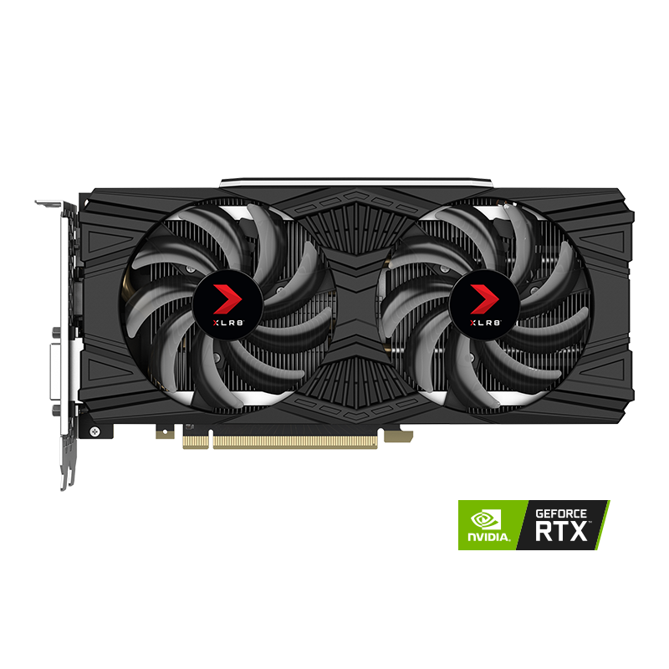

**PNY® GeForce RTX™ 2060 6GB XLR8 Gaming Overclocked Edition**

The PNY® GeForce RTX™ 2060 6GB XLR8 Gaming Overclocked Edition has been carefully crafted with a dual fan design to allow maximum airflow, ensuring superior cooling and unwavering performance. Equipped with the latest technologies such as high-speed GDDR6 memory, Real-Time Ray Tracing, Nvidia Ansel, etc. the PNY® GeForce RTX™ 2060 6GB XLR8 Gaming Overclocked Edition is ready for all gaming needs.

Supporting PNY’s Velocity X Overclocking Software, the PNY® GeForce RTX™ 2060 6GB XLR8 Gaming Overclocked Edition allows for full monitoring of its clocks, temperatures, and speed, as well as select customization to ensure optimum use of the GPU and deliver the best experience to PC enthusiasts and gamers.

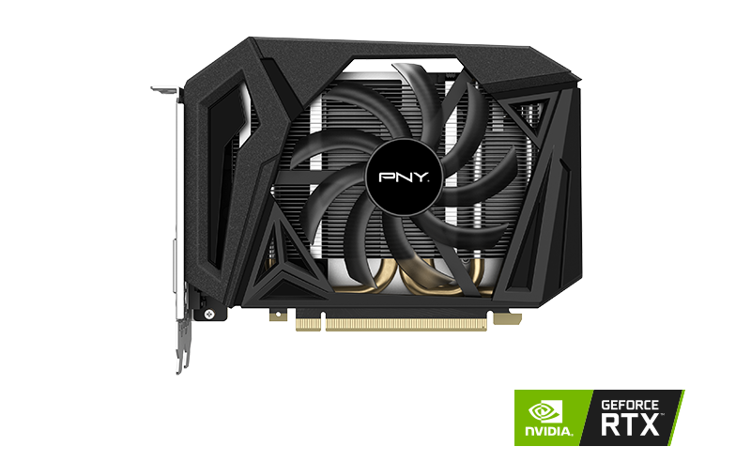

**PNY® GeForce RTX™ 2060 6GB Single Fan**

The PNY GeForce® RTX 2060 6GB Single Fan takes advantage of the cutting-edge NVIDIA Turing™ architecture to immerse enthusiasts in the latest game titles with incredible realism and performance. Relying on a compact design, the PNY GeForce RTX™2060 6GB Single Fan is a great solution for anyone looking for a balance of incredible gaming performance and small form factor.

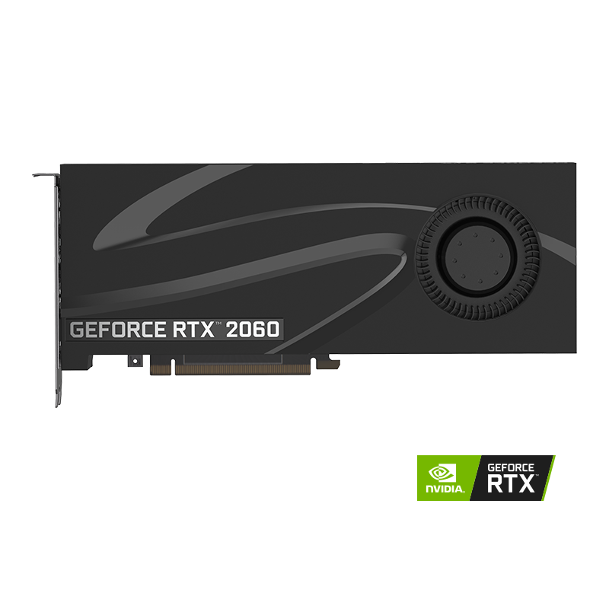

**PNY® GeForce RTX™ 2060 6GB Blower**

Engineered with reliability and stability in mind the PNY® GeForce RTX™ 2060 6GB Blower thermal design is built around a radial fan that allows for optimized airflow, pushing all the hot air from the PC via a rear exhaust while keeping the computer temperatures in check. Equipped with the latest technologies such as high-speed GDDR6 memory and Real-Time Ray Tracing, the PNY® GeForce RTX™ 2060 6GB Blower is ready for the most demanding tasks.

**Availability**

Selected PNY® GeForce RTX™ 2060graphics cards will be available starting January 15th, at leading retail and etail partners.

**Keep Current on PNY Technologies and XLR8 Gaming**

Follow **@PNYUSA** and **@XLR8Gam1ng** on [Facebook](https://www.facebook.com/pnyusa/), [Twitter](https://twitter.com/PNYTechnologies), [Instagram](https://www.instagram.com/pnytechnologies/) and join our corporate community on [LinkedIn](https://www.linkedin.com/company/pny-technologies).

**About PNY Technologies and XLR8 Gaming**

Established in 1985, PNY Technologies®, Inc. celebrates over 30 years of business excellence as a global manufacturer and supplier of flash memory cards, USB and OTG flash drives, solid state drives, computer memory upgrade modules, NVIDIA® GeForce® consumer graphics cards and NVIDIA® Quadro® professional graphics cards. The company’s Photo/Video, Mobility, Gaming, Visualization and Professional solutions are widely available from major retail, e-tail and wholesale outlets internationally.

XLR8 Gaming, PNY® Technologies’ brand designed for gaming and modding enthusiasts powers their journey towards the ultimate PC experience.

Headquartered in Parsippany, NJ, PNY® maintains facilities in North America, Europe, Asia, Middle East, India and Latin America. More information www.pny.com, [www.xlr8gam1ng.com](http://www.xlr8gam1ng.com)