PRESS RELEASE

PNY® expands its storage lineup with the new XLR8 CS2311 2.5” SATA III and
Pro Elite USB 3.1 Gen 2 Type-C Portable SSDs

Parsippany, January 4th, 2019 — PNY® Technologies announces the expansion of its SSD lineup with the introduction of the high-density PNY® XLR8 CS2311 2.5” SATA III, offering up to 2 TB of internal storage, and the PNY® Pro Elite USB 3.1 Gen 2 Type-C Portable SSD bringing extreme performance and reliability to mobile storage.

Combining speed, reliability and endurance, PNY® XLR8 CS2311 2.5” SATA III SSDs are designed to provide a high performance HDD replacement in gaming or mainstream PC systems, improving both boot times and application launches. The PNY® XLR8 CS2311 2.5” SATA III SSDs provide exceptional performances offering up to 560MB/s seq. read and 530MB/s seq. write speeds. Crafted for durability, PNY® XLR8 CS2311 2.5” SATA III SSDs are backed with a 5-Year warranty and available in a wide array of densities ranging from 250GB up to 2TB.

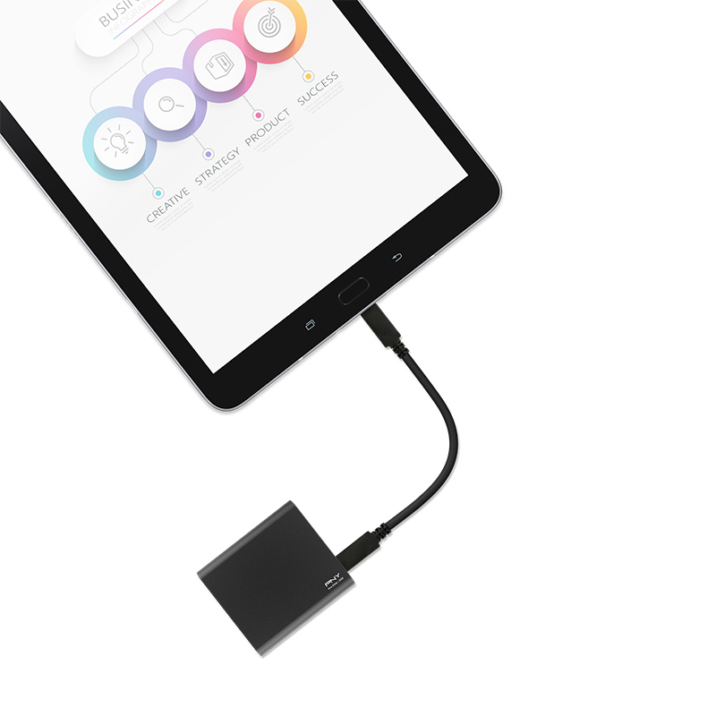

For users on the go, the PNY® Pro Elite USB 3.1 Gen 2 Type-C Portable SSD provides extended capacities without compromising on performance. With read and write speeds of up to 890MB/s and 900MB/s, PNY® Pro Elite USB 3.1 Gen 2 Type-C Portable SSDs provide transfer speeds of up to 30 times faster than a USB 3.0 flash drive. Sleek and compact, the PNY® Pro Elite SSD features a Type C Connector, making it compatible with both USB-A and USB-C enabled host devices via the included USB Type-C to C cable and USB Type-C to A cable, right in the box.

Jonathan Yu, Components Product Marketing Manager said: “In an all-digital world, preserving data has become key to businesses and personal lives, whether dealing with storing files on the go or in a computer, at PNY®, we envision that all of our products will provide innovative and reliable solutions for safeguarding users data. Our PNY® XLR8 CS2311 2.5” SATA III and Pro Elite USB 3.1 Gen 2 Type-C SSDs are built with that vision in mind, and will definitely provide a fast and solid alternative to traditional storage options.”

Product Specifications

 | PNY® XLR8 CS2311 2.5” SATA III Solid State Drive
 | Capacity | Interface | Seq. Read up to | Seq. Write up to |  | IOPS Read  up to |  | IOPS Write  up to |  | MTBF | Warranty
 | 250GB | SATA III | 560 MB/s | 530 MB/s |  | 100,000 |  | 90,000 |  | 2 Million Hours | 5 Year
 | 500GB |  | 560 MB/s | 530 MB/s |  | 100,000 |  | 90,000
 | 1TB |  | 560 MB/s | 530 MB/s |  | 100,000 |  | 90,000
 | 2TB |  | 560 MB/s | 530 MB/s |  | 100,000 |  | 90,000
PNY® Pro Elite USB 3.1 Gen 2 Type-C Portable Solid State Drive
Capacity |  | Interface | Seq. Read up to | Seq. Write up to | Housing Material |  | Warranty |  | Software Included | Cables Included
250GB |  | USB 3.1 Gen 2 | 880 | 900 | Aluminum |  | 3 Year |  | Acronis Data Protection | USB-C to USB-C  USB-C to USB-A
500GB |  |  | 865 | 875
1TB |  |  | 890 | 880

Availability
PNY® XLR8 CS2311 2.5” SATA III will be available and PNY® Pro Elite USB 3.1 Gen 2 Type-C Portable Solid State Drives will be available starting Q1 of 2019, at leading retail and etail partners.

Keep Current on PNY® Technologies and XLR8 Gaming
Follow @PNYUSA and @XLR8Gam1ng on Facebook, Twitter, Instagram and join our corporate community on LinkedIn.

About PNY® Technologies and XLR8 Gaming

Established in 1985, PNY Technologies®, Inc. celebrates over 30 years of business excellence as a global manufacturer and supplier of flash memory cards, USB and OTG flash drives, solid state drives, computer memory upgrade modules, NVIDIA® GeForce® consumer graphics cards and NVIDIA® Quadro® professional graphics cards. The company’s Photo/Video, Mobility, Gaming, Visualization and Professional solutions are widely available from major retail, e-tail and wholesale outlets internationally.

XLR8 Gaming, PNY® Technologies’ brand designed for gaming and modding

enthusiasts powers their journey towards the ultimate PC experience.

Headquartered in Parsippany, NJ, PNY® maintains facilities in North America, Europe, Asia, Middle East, India and Latin America. More information www.pny.com, www.xlr8gam1ng.com

